Understanding Spring Boot Architecture Flow


Spring Boot is a powerful framework that simplifies the development of enterprise-grade applications by providing a pre-configured setup that allows developers to focus more on writing business logic rather than managing configuration. In this post, we’ll dive into the architecture flow of a typical Spring Boot application, helping you understand how the components interact and how requests are processed from start to finish.

1. The Core Components of Spring Boot Architecture
Before we delve into the flow, it’s essential to understand the core components that make up a Spring Boot application:
- Spring Framework: The backbone of Spring Boot, providing dependency injection, AOP, and transaction management.
- Embedded Server: Spring Boot applications usually run with an embedded server (Tomcat, Jetty, or Undertow), making them self-contained and easy to deploy.
- Auto-Configuration: This feature automatically configures Spring components based on the dependencies present in the project.
- Spring Boot Starter Dependencies: Simplified dependency management with pre-configured starter packages like spring-boot-starter-web, spring-boot-starter-data-jpa, etc.
- Spring Boot Actuator: Provides built-in endpoints for monitoring and managing the application.

2. Request Handling in Spring Boot
Let’s walk through the flow of a request in a typical Spring Boot application:

Step 1: Client Request
A client (browser, mobile app, etc.) sends an HTTP request to the Spring Boot application. The request is routed to the appropriate port on which the embedded server (e.g., Tomcat) is listening.

Step 2: DispatcherServlet
The embedded server receives the request and forwards it to the DispatcherServlet, which is the central dispatcher for HTTP requests. It handles all incoming requests and delegates them to appropriate components.

Step 3: Handler Mapping
The DispatcherServlet consults HandlerMapping to determine the appropriate Controller that should handle the request. HandlerMapping uses annotations like @RequestMapping to map URLs to specific controller methods.

Step 4: Controller and Service Layer
Once the appropriate controller method is identified, the DispatcherServlet invokes it. The controller method may interact with the service layer, where the business logic resides. The service layer, in turn, may interact with the data access layer (typically using Spring Data JPA) to perform CRUD operations on the database.

Step 5: Data Access and Repositories
The service layer uses repositories (interfaces that extend CrudRepository, JpaRepository, etc.) to interact with the database. Spring Data JPA automatically implements these repository methods, providing an abstraction over the database.

Step 6: Response Handling
After the controller processes the request, it returns a ModelAndView object or a JSON/XML response (in RESTful services). The ViewResolver then resolves the logical view name to a physical view (like a JSP page), or the response is directly sent back to the client.

Step 7: DispatcherServlet Response
The DispatcherServlet sends the final response back to the client via the embedded server. This response could be an HTML page, JSON data, or an error message, depending on the request type and the outcome of the processing.

3. Spring Boot Auto-Configuration
One of the key features of Spring Boot is its auto-configuration capability. When you run a Spring Boot application, it automatically configures your application based on the JAR dependencies available in the classpath. For instance, if spring-boot-starter-web is present, Spring Boot auto-configures a web application with necessary components like DispatcherServlet, ViewResolver, and so on.
This eliminates the need for manual configuration, allowing developers to get started quickly with minimal setup. However, it’s also possible to override these configurations if custom behavior is needed.

4. Spring Boot Actuator
For monitoring and managing a Spring Boot application, the Actuator module provides several endpoints that expose operational information. These endpoints can be used to check application health, metrics, environment properties, and more.

Example of Actuator Endpoints:
- /actuator/health: Provides health status of the application.
- /actuator/metrics: Exposes various metrics related to the application’s performance.
Actuator is an essential tool for maintaining application performance and health in production environments.

5. Putting It All Together
The Spring Boot architecture flow is designed to streamline the development process, offering a clear and efficient path for request processing from client to server and back. By understanding this flow, developers can better leverage the framework to build scalable, maintainable applications.
Key Takeaways:
- Spring Boot abstracts much of the configuration complexity, allowing developers to focus on business logic.
- The DispatcherServlet plays a critical role in handling requests and routing them to appropriate controllers.
- The service and repository layers follow a clear separation of concerns, making the application easier to manage and extend.
- Auto-Configuration and Actuator are powerful features that enhance productivity and application management.
Understanding the Spring Boot architecture flow not only helps in better design but also in troubleshooting and optimizing your applications. Whether you’re building a simple RESTful service or a complex enterprise application, knowing how the pieces fit together is crucial for success.

Spring Boot - Architecture

Spring Boot is built on top of the core Spring framework. It simplifies and automates Spring-based application development by reducing the need for manual configuration. Spring Boot follows a layered architecture, where each layer interacts with other layers in a hierarchical order. The official Spring Boot documentation defines it as:
"Spring Boot makes it easy to create stand-alone, production-grade Spring-based applications with minimal configuration."
The main goal of Spring Boot is to eliminate XML and annotation-based configuration complexities. It provides several benefits, including opinionated defaults, convention over configuration, stand-alone applications, and production readiness.

Spring Boot Layers
Spring Boot consists of the following four layers:
- Presentation Layer: Handles HTTP requests, authentication, and JSON conversion.
- Business Layer: Contains business logic, validation, and authorization.
- Persistence Layer: Manages database interactions using ORM frameworks like Spring Data JPA.
- Database Layer: Stores application data using relational (MySQL, PostgreSQL) and NoSQL databases (MongoDB, DynamoDB).
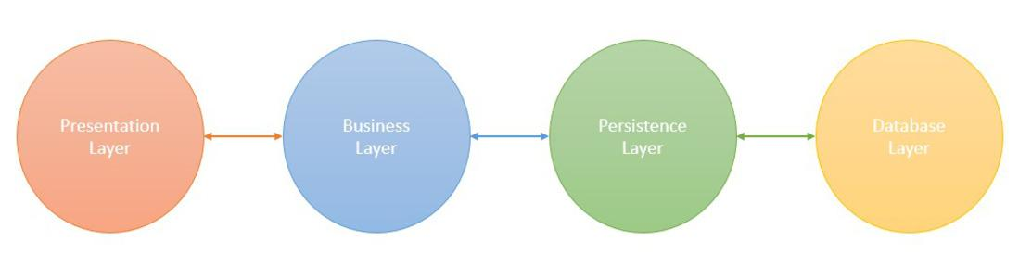

1. Presentation Layer
The Presentation Layer is the topmost layer of the Spring Boot architecture. It primarily consists of REST controllers that handle HTTP requests (GET, POST, PUT, DELETE). It performs authentication, request validation, and JSON serialization/deserialization (conversion of JSON to Java objects and vice versa). After processing the request, it forwards the request to the business layer.

2. Business Layer
The Business Layer is responsible for implementing the application's core logic. It consists of service classes that:
- Process and validate data.
- Handle authentication and authorization (integrating Spring Security if needed).
- Apply transaction management using @Transactional.
- Interact with the Persistence Layer to store or retrieve data.

3. Persistence Layer
The Persistence Layer manages database transactions and storage logic. It consists of repository classes using Spring Data JPA, Hibernate, or R2DBC for data access. It is responsible for:
- Mapping Java objects to database records using ORM frameworks.
- Managing CRUD (Create, Read, Update, Delete) operations.
- Supporting relational and NoSQL databases.

4. Database Layer
The Database Layer contains the actual database where the application data is stored. It can support:
- Relational Databases (MySQL, PostgreSQL, Oracle, SQL Server).
- NoSQL Databases (MongoDB, Cassandra, DynamoDB, Firebase).
- Cloud-based databases for scalability.

Spring Boot Flow Architecture
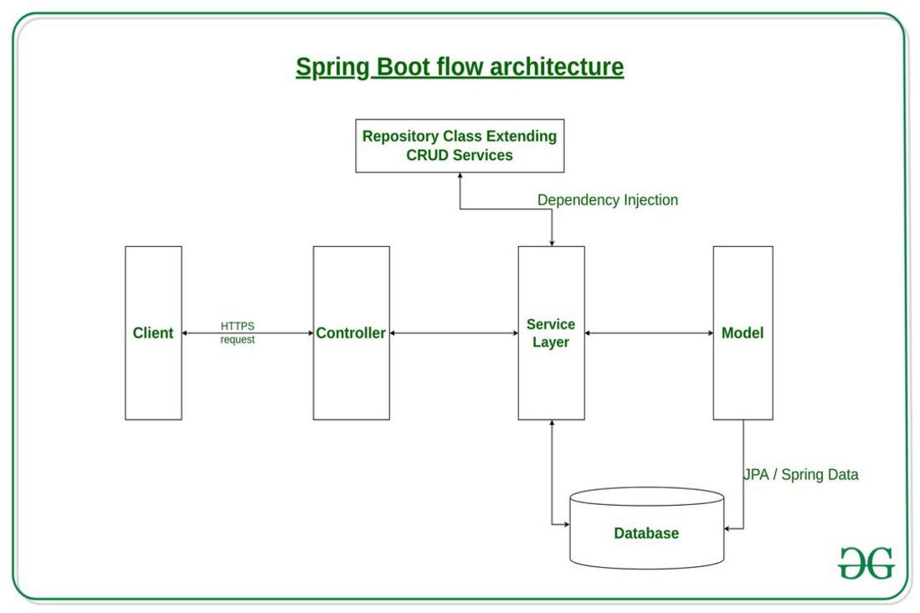

Explanation:
- The client (frontend or API consumer) sends an HTTP request (GET, POST, PUT, DELETE) to the application.
- The request is handled by the Controller Layer, which maps the request to a specific handler method.
- The Service Layer processes business logic and communicates with the Persistence Layer to fetch or modify data.
- The Persistence Layer interacts with the Database Layer using Spring Data JPA or R2DBC, often through a Repository Class that extends CRUD services.
- The processed response is returned as JSON.
- Spring Boot Actuator can be used for monitoring and health checks.

Spring Boot - Spring Data JPA
Last Updated : 03 Apr, 2024

Spring Data JPA or JPA stands for Java Persistence API, so before looking into that, we must know about ORM (Object Relation Mapping). So Object relation mapping is simply the process of persisting any java object directly into a database table. Usually, the name of the object being persisted becomes the name of the table, and each field within that object becomes a column. With the table setup, each row corresponds to a record in the application. Hibernate is one example of ORM. In short, JPA is the interface while hibernate is the implementation.
The java persistence API provides a specification for persisting, reading, and managing data from your java object to your relational tables in the database. JPA specifies the set of rules and guidelines for developing interfaces that follow standards. Straight to the point: JPA is just guidelines to implement ORM and there is no underlying code for the implementation. Spring Data JPA is part of the spring framework. The goal of spring data repository abstraction is to significantly reduce the amount of boilerplate code required to implement a data access layer for various persistence stores. Spring Data JPA is not a JPA provider, it is a library/framework that adds an extra layer of abstraction on the top of our JPA provider line Hibernate.

Configure Spring Data JPA in Spring Application with Example
Requirements: STS IDE, MySQL workbench, Java 8+
Create a spring boot project in STS. Give project name & select add required dependencies(Spring JPA, MySQL driver, Spring web) shown in attached pom.xml.
<?xml version="1.0" encoding="UTF-8"?>
<project xmlns="http://maven.apache.org/POM/4.0.0" xmlns:xsi="http://www.w3.org/2001/XMLSchema-instance"
xsi:schemaLocation="http://maven.apache.org/POM/4.0.0 https://maven.apache.org/xsd/maven-4.0.0.xsd">
<modelVersion>4.0.0</modelVersion>
<parent>
<groupId>org.springframework.boot</groupId>
<artifactId>spring-boot-starter-parent</artifactId>
<version>2.6.1</version>
<relativePath/> <!-- lookup parent from repository -->
</parent>
<groupId>com.example</groupId>
<artifactId>ex</artifactId>
<version>0.0.1-SNAPSHOT</version>
<name>ex</name>
<description>Demo project for Spring Boot</description>
<properties>
<java.version>11</java.version>
</properties>
<dependencies>
<dependency>
<groupId>org.springframework.boot</groupId>
<artifactId>spring-boot-starter-data-jpa</artifactId>
</dependency>
<dependency>
<groupId>org.springframework.boot</groupId>
<artifactId>spring-boot-starter-web</artifactId>
</dependency>

<dependency>
<groupId>org.springframework.boot</groupId>
<artifactId>spring-boot-devtools</artifactId>
<scope>runtime</scope>
<optional>true</optional>
</dependency>
<dependency>
<groupId>mysql</groupId>
<artifactId>mysql-connector-java</artifactId>
<scope>runtime</scope>
</dependency>
<dependency>
<groupId>org.springframework.boot</groupId>
<artifactId>spring-boot-starter-test</artifactId>
<scope>test</scope>
</dependency>
</dependencies>

<build>
<plugins>
<plugin>
<groupId>org.springframework.boot</groupId>
<artifactId>spring-boot-maven-plugin</artifactId>
</plugin>
</plugins>
</build>
</project>
OR you can also add these dependencies while creating the project.
application.properties file:
spring.datasource.url=jdbc:mysql://localhost:3306/emp
spring.datasource.username=root
spring.datasource.password=root
spring.datasource.driver-class-name=com.mysql.cj.jdbc.Driver
spring.jpa.database-platform = org.hibernate.dialect.MySQL5Dialect
spring.jpa.generate-ddl=true
spring.jpa.hibernate.ddl-auto = update
Project Structure:
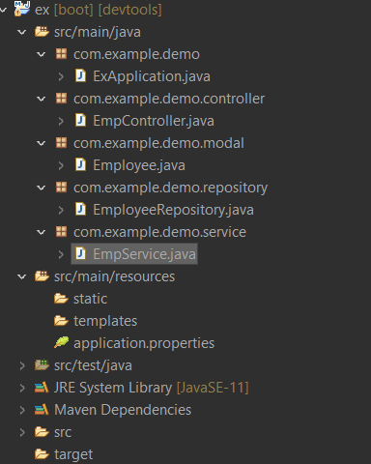
Modal layer:
Create a simple POJO(Plain old java class) with some JPA annotation.
- @Entity: This annotation defines that a class can be mapped to a table
- @Id: This annotation specifies the primary key of the entity.
- @GeneratedValue: This annotation is used to specify the primary key generation strategy to use. i.e. Instructs database to generate a value for this field automatically. If the strategy is not specified by default AUTO will be used.
package com.example.demo.modal;

import javax.persistence.Entity;
import javax.persistence.GeneratedValue;
import javax.persistence.GenerationType;
import javax.persistence.Id;

// @Entity annotation defines that a
// class can be mapped to a table
@Entity
public class Employee {

// @ID This annotation specifies
// the primary key of the entity.
@Id

// @GeneratedValue This annotation
// is used to specify the primary
// key generation strategy to use
@GeneratedValue(strategy = GenerationType.AUTO)
private long id;
private String name;
private String city;

public Employee() {
super();
}
public Employee(String name, String city) {
super();
this.name = name;
this.city = city;
}

public String getName() {
return name;
}

public void setName(String name) {
this.name = name;
}

public String getCity() {
return city;
}

public void setCity(String city) {
this.city = city;
}

}
DAO(Data access object) layer:
- @Repository: The @Repository annotation is a marker for any class that fulfills the role or stereotype of a repository (also known as Data Access Object or DAO).
- JpaRepository<Employee, Long> JpaRepository is a JPA-specific extension of the Repository. It contains the full API of CrudRepository and PagingAndSortingRepository. So it contains API for basic CRUD operations and also API for pagination and sorting. Here we enable database operations for Employees.
package com.example.demo.repository;

import org.springframework.data.jpa.repository.JpaRepository;
import org.springframework.stereotype.Repository;

import com.example.demo.modal.Employee;

// @Repository is a Spring annotation that
// indicates that the decorated class is a repository.
@Repository
public interface EmployeeRepository extends JpaRepository<Employee, Long>{
ArrayList<Employee> findAllEmployee();
}
Service layer:
package com.example.demo.service;
import java.util.ArrayList;
import com.example.demo.modal.Employee;
public interface EmpService {
ArrayList<Employee> findAllEmployee();
Employee findAllEmployeeByID(long id);
void addEmployee();
void deleteAllData();
}
@Service: This annotation is used with classes that provide some business functionalities. Spring context will autodetect these classes when annotation-based configuration and classpath scanning is used. Here JPA repository has lots of predefined generic methods to perform the database operation some are used in the below code.
package com.example.demo.service;
import java.util.ArrayList;
import java.util.Iterator;
import java.util.Optional;
import org.springframework.beans.factory.annotation.Autowired;
import org.springframework.stereotype.Service;
import com.example.demo.modal.Employee;
import com.example.demo.repository.EmployeeRepository;

// @Service marks a Java class that performs some service,
// such as executing business logic, performing
// calculations, and calling external APIs.
@Service
public class EmpServiceImpl implements EmpService {
@Autowired
EmployeeRepository employeeRepository;

@Override
public ArrayList<Employee> findAllEmployee() {
return (ArrayList<Employee>) employeeRepository.findAll();
}

@Override
public Employee findAllEmployeeByID(long id) {
Optional<Employee> opt = employeeRepository.findById(id);
if (opt.isPresent())
return opt.get();
else
return null;
}

@Override
public void addEmployee() {
ArrayList<Employee> emp = new ArrayList<Employee>();
emp.add(new Employee("Lucknow", "Shubham"));
emp.add(new Employee("Delhi", "Puneet"));
emp.add(new Employee("Pune", "Abhay"));
emp.add(new Employee("Noida", "Anurag"));
for (Employee employee : emp) {
employeeRepository.save(employee);
}
}

@Override
public void deleteAllData() {
employeeRepository.deleteAll();
}
}
Controller layer:
- @RestController: This is a Spring annotation that is used to build REST API in a declarative way. RestController annotation is applied to a class to mark it as a request handler, and Spring will do the building and provide the RESTful web service at runtime.
- @Autowired: This annotation can be used to autowire bean on the setter method just like @Required annotation, constructor, a property, or methods with arbitrary names and/or multiple arguments.
- @PostMapping: This annotation maps HTTP POST requests onto specific handler methods. It is a composed annotation that acts as a shortcut for @RequestMapping(method = RequestMethod. POST)
- @GetMapping: This annotation is a specialized version of @RequestMapping annotation that acts as a shortcut for @RequestMapping(method = RequestMethod. GET). The @GetMapping annotated methods in the @Controller annotated classes handle the HTTP GET requests matched with the given URI expression.
- @DeleteMapping: This annotation maps HTTP DELETE requests onto specific handler methods. It is a composed annotation that acts as a shortcut for @RequestMapping(method = RequestMethod. DELETE)
package com.example.demo.controller;
import java.util.ArrayList;
import org.springframework.beans.factory.annotation.Autowired;
import org.springframework.web.bind.annotation.DeleteMapping;
import org.springframework.web.bind.annotation.GetMapping;
import org.springframework.web.bind.annotation.PathVariable;
import org.springframework.web.bind.annotation.PostMapping;
import org.springframework.web.bind.annotation.RestController;
import com.example.demo.modal.Employee;
import com.example.demo.service.EmpServiceImpl;

@RestController
public class EmpController {

@Autowired
EmpServiceImpl empServiceImpl;

@PostMapping("/")
public void add() {
empServiceImpl.addEmployee();
}

@GetMapping("/findall")
public ArrayList<Employee> getAllEmployee() {
return empServiceImpl.findAllEmployee();
}

@GetMapping("/findbyid/{id}")
public Employee getEmployeeUsingId(@PathVariable long id) {
return empServiceImpl.findAllEmployeeByID(id);
}

@DeleteMapping("/delete")
public void delete() {
empServiceImpl.deleteAllData();
}
}
Display output using JPA in postman:
Open postman and hit the listed API one by one.
Save employee data

Find all employee list
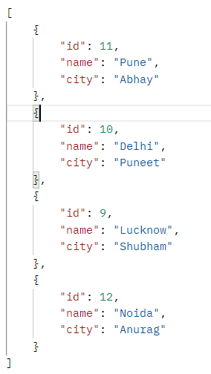
Find an employee by id
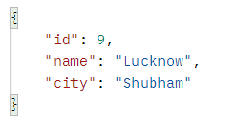
Delete all employee


